**Code9: Return**

#include<stdio.h>

#include<stdlib.h>

double cube(double num){

double result = num * num * num;

return result;

}

int main() {

printf("Answer: %f", cube(3.0));

return 0;

}

Output:

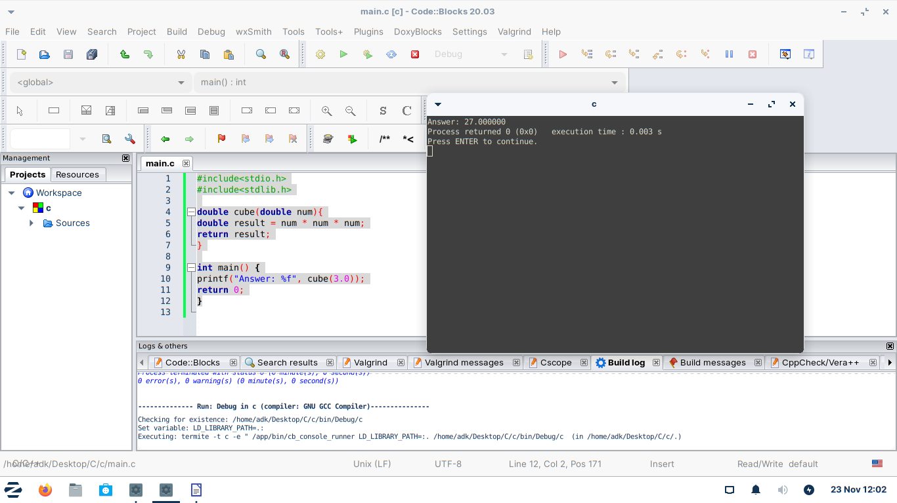

**code10:If loop**

#include<stdio.h>

#include<stdlib.h>

int max(int num1, int num2){

int result;

if(num1 > num2){

result = num1;

}

else {

result = num2;

}

}

int main() {

printf("%d", max(4, 10));

return 0;

}

Output:

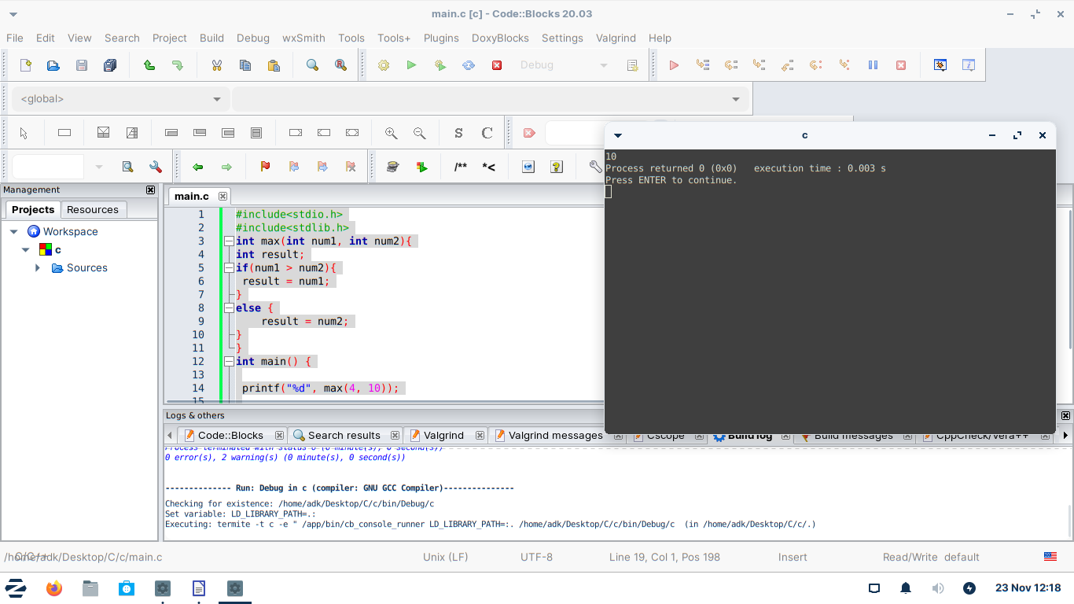

**Code11:Building a better calculator.**

#include <stdio.h>

#include <stdlib.h>

int main()

{

double num1;

double num2;

char op;

printf("Enter a Number :");

scanf("%lf", &num1);

printf("Enter operator :");

scanf(" %c", &op);

printf("Enter 2nd Number :");

scanf("%lf", &num2);

if(op == '+'){

printf("%f", num1 + num2);

} else if(op == '-'){

printf("%f", num1 - num2);

} else if(op == '*'){

printf("%f", num1 * num2);

} else if(op == '/'){

printf("%f", num1 / num2);

} else {

printf("invalid operator.");

}

Output:

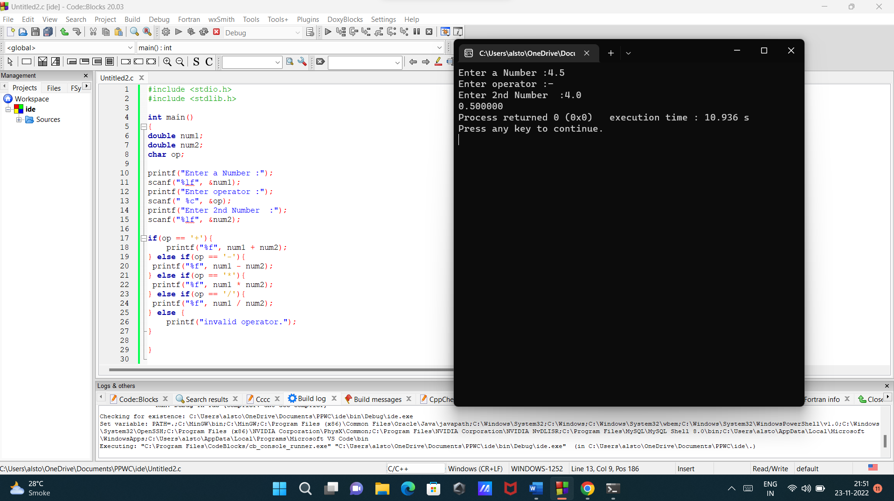

**Code12: Switch**

#include <stdio.h>

#include <stdlib.h>

int main()

{

char grade = 'A';

switch(grade) {

case 'A' :

printf("You did great!");

break;

case 'B' :

printf("You did alright!");

break;

case 'C' :

printf("You did poorly!");

break;

case 'D' :

printf("You did very bad!");

break;

case 'F' :

printf("You Failed!");

break;

default :

printf("invalid grade");

}

return 0;

}

Output:

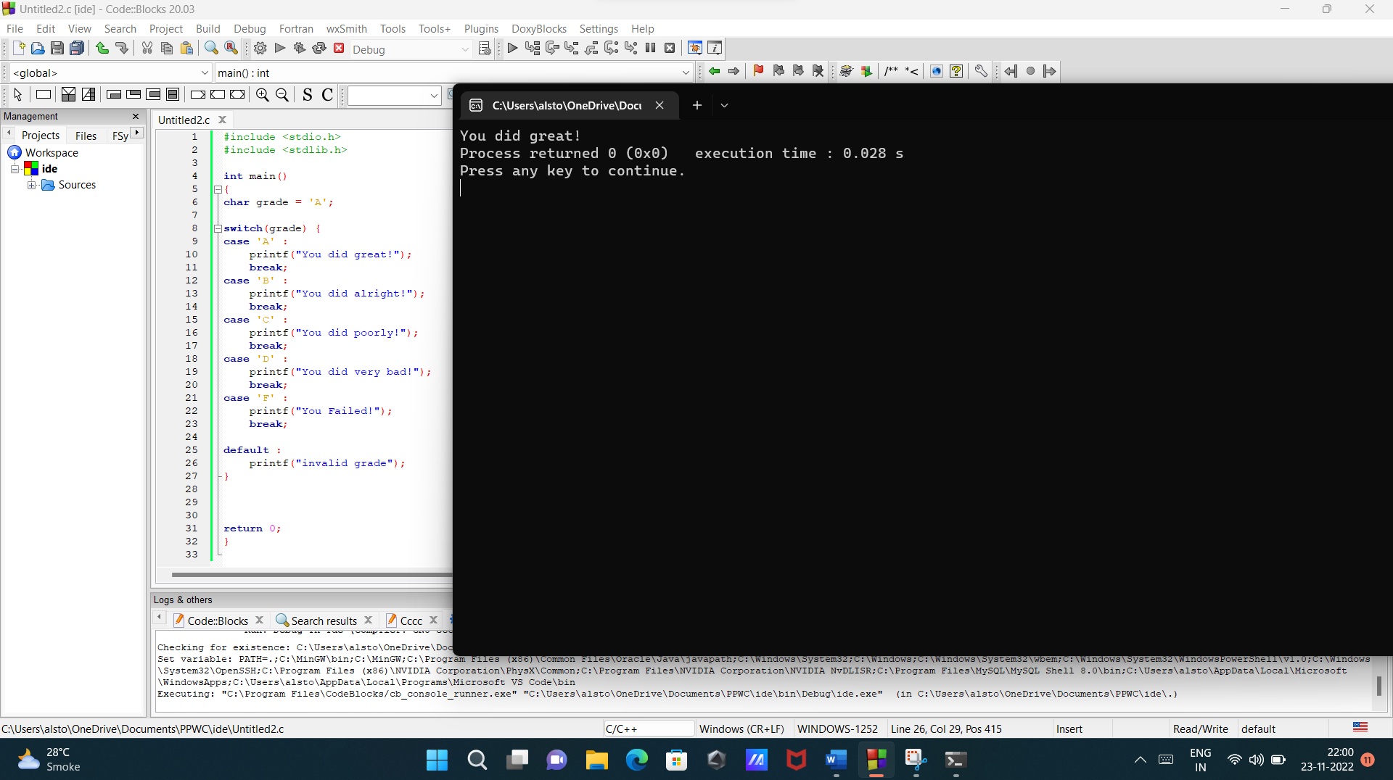

**Code13: Struct**

#include <stdio.h>

#include <stdlib.h>

struct Student{

char name[50];

char major[50];

int age;

double gpa;

};

int main(){

struct Student student1;

student1.age = 22;

student1.gpa = 3.2;

strcpy( student1.name, "Jim");

strcpy( student1.major, "IT");

printf("%f", student1.gpa);

return 0;

}

Output:

